**Genocide Alert! China is wiping off everyone.**

There has been evidence and news all around the globe generating global anger and frustration against China. The reason has been that the Chinese Communist Party has been trying to come up with ways to eradicate other religions and rule across the planet.

There had been many controversies about the Covid-19 outbreak from China and soon after its spread, the betterment and successful treatments of the Chinese Covid-19 affected citizens. Few people even say that this was all planned by China to get ahead of other nations in terms of development and success.

Not only has the CORONA for targeting other countries, CPC not even left their own citizens targeting them because of their religion!

Uyghur’s who are the Muslims of China have been forced and tempted with several severe issues so as to convert their religion, leave Islam, and opt for Mandarin.

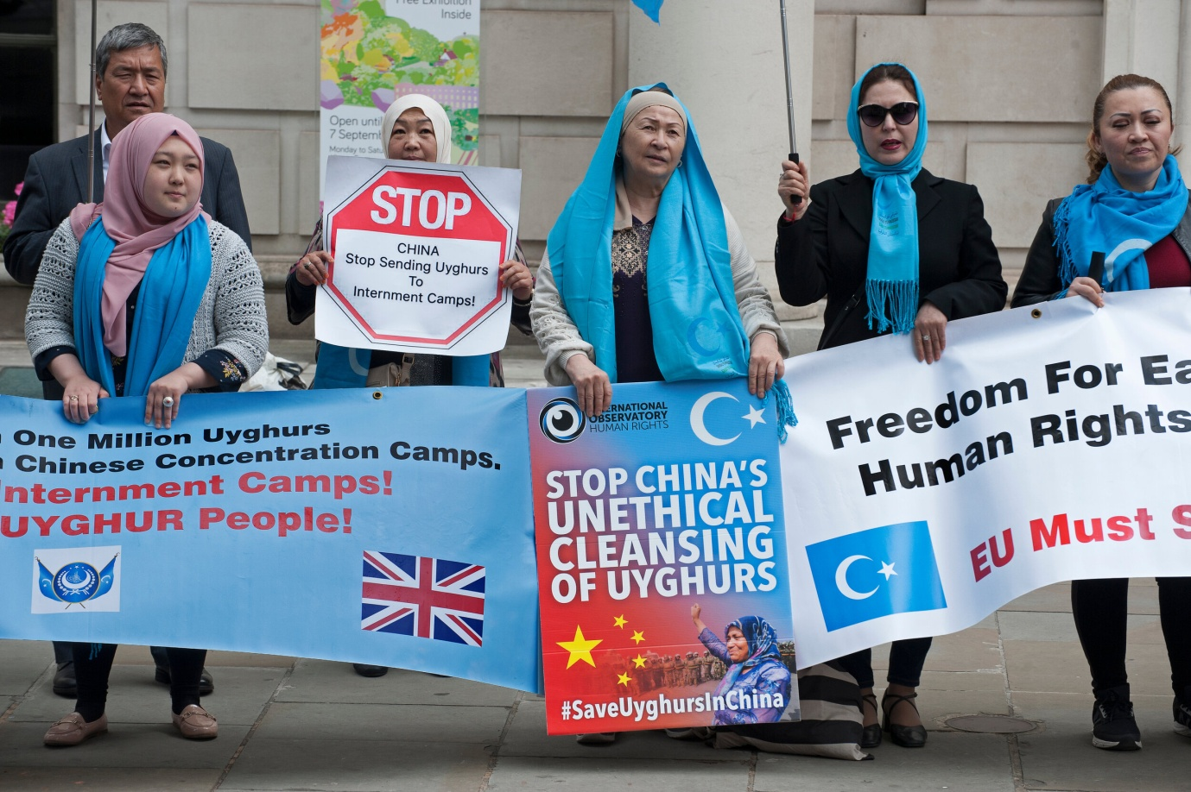

**Uyghur Crisis!**

Pieces of evidence have been into sights stating how Uyghur’s of China not only face humanity crimes but also GENOCIDE!

*Convention on the Prevention and Punishment of the Crime of Genocide,* in its Article II (d), stated itself that measures to prevent birth in a group or a community are evidence of Genocide. Blowing the minds, there are a few facts and figures revolving around the Uyghur community of China, like:

* This Muslim community is forced for sterilizations and birth controls. Too many children are one of the reasons why they are snatched away from their families, to move to the camps and children to the boarding houses.
* Since 2017, The Chinese government has been opting for various evil and monstrous birth control measures for the Uyghur community. Starting from dragnet-style investigations of Muslim families to mandatory checks and the forced insertions of intrauterine devices, CCP officials and government agents look for pregnant Uyghur women and small children at night.
* Uyghur families with 3 or more children are imposed fines and Xinjiang region detention camps are used for these people. Doctors who help these pregnant women are sent to the detention camps too.
* Uyghur children are snatched away from their parents to go to any boarding house or government orphanages where they are stripped of their Islamic Uyghur identities.
* Around about 2 million Uyghur’s went to the detention camps where they were forced with other crimes including rape, organ harvesting, and extrajudicial killings, all in the name of ‘re-education’.
* In 2019, CPC documents stated that they were going after 80% of the Uyghur women in South Xinjiang as targeted for forced sterilizations, and other birth control measures.
* For 2020, Beijing set zero population growth targets for the Uyghurs.
* The forced sterilization reduced Uyghur birth rates by 24% in 2020.

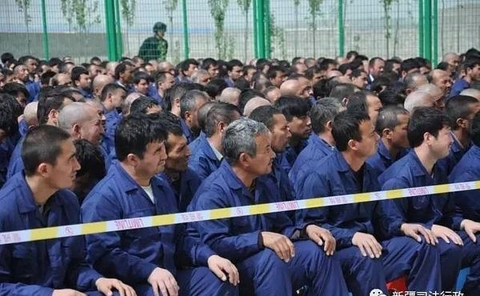

**Humanity issues under our noses!**

Leaders of Uyghur Human Rights Projects (UHRP) warned China’s extra-territorial reach stating how even Australian Uyghur’s are suffering by the hands of Chinese states.

Historians already know how Hitler’s detention camps proved out for their communities. Now, CPC is also finding a final solution for Xinjiang as stated by Beijing’s officials.

What is happening in Xinjiang is a form of GENOCIDE!

Since 2014, Uyghur’s relatives from Sydney including an activist Sultan Hiwilla haven’t had any word with their Chinese families.

As stated by UHRP head, Nury Turkel, Something horrifying is happening on our watch, and we need to take action! Turkel also stated that Mass Murder is happening in the Chinese detention camps! Uyghurs of China are actually going through a spine-chilling situation with each passing day, facing more severe life threats and human rights violations.

An alarming situation is going on around China with an unpleasant and terrifying situation for the Muslim Uyghur community. What is happening in China is not only a threat to the Uyghur community of China but is also petrifying for humanity! These detention camps are a curse to the Uyghurs where they are tortured to such extent that they pray to DIE instead of LIVING in such hell. In the 21st century, even with such advancements and success, CPC is opting for such cruel methods against a religious community, aiming to make China an only Chinese nation, and then wipe away all the other nations and rule across the globe!

In 2020, USCIRF released a factsheet on how CPC is targeting to restrict religious freedom. Thus, the administration was called upon by USCIRF under the Global Magnitsky Human Rights Accountability Act and the International Religious Freedom Act to impose sanctions over the Chinese officials responsible for the freedom violations and other issues, including Genocide and forced Sterilization. The current Communist Party Secretary of Xinjiang, Chen Quanguo is to be questioned for the same!

Each and every minor and major community deserves equality and freedom to practice their own religion and culture, irrespective of their nation, their cast, and their beliefs!

